**Project to Digitize products of Company Lockers Pvt. Ltd.**

**Background of the problem statement:**

Company Lockers Pvt. Ltd. hired you as a Full Stack Developer. They aim to digitize their products and chose LockedMe.com as their first project to start with.

**Sprints :**

I have decided to complete entire project in two sprint. First sprint to prepare Flowchart and Algorithms. And also planed to use what are software to use. Second sprint I have implemented code using Eclipse and uploaded to GitHub.

* It requires two sprints to complete the application.
* Product owner: Company Lockers Pvt. Ltd.

**Flowchart:**

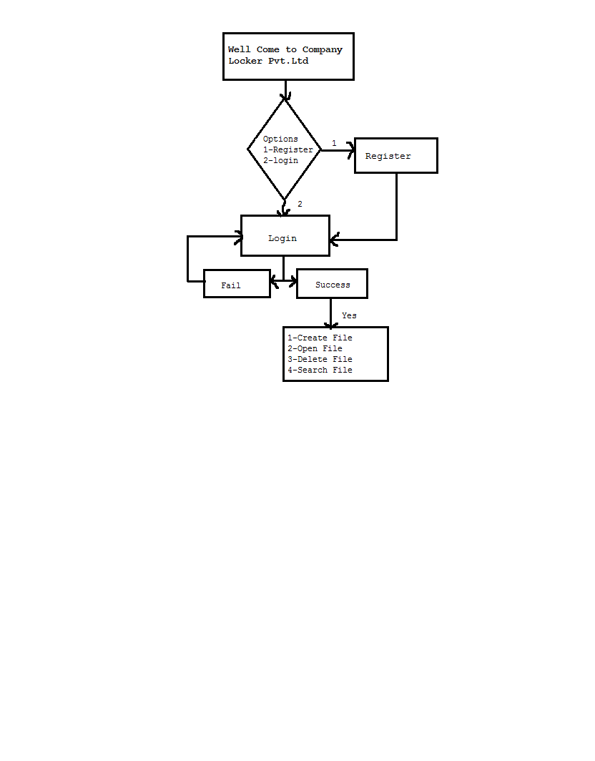

**Algorithms:**

1. **Void Display():** Function To display Well come message . When user visits to the page, it shows the well come message.

**Void Option():** Function to display options to users . When user visits to the page, it shows two options to users to Register/Login.

* **Option 1) Registration ():** Allowed users to provide user name and Password and it is stored it in specific file.
* **Option 2) Login():** Provide access to user by username and password.

1. **Void Registration()**: Function to register user using there username and password. If user chose to register , it asks user for username and password and store it in database.
2. **Void Login():** Function to login users using username and password.

User has to provide correct username and password to login.

1. **Void Option1():** Function to display options to users .

* **Option 1) Create New File ():** Allow users to create new file in specific folder.
  + Option to add a user specified file to the application.
  + Provide where file is to be stored.
* **Option 2) Open File():**  It provide users open new file in specified location.
* **Option 3)Delete File():** It provide users Delete new file in specified location.
* **Option 4)Search File():**When a user wants to verify if a user exists or not, search by file name in project folder. If the username provided exists show user exists, else does not exists.

**GitHub Repository:**

Git Repository link: **https://github.com/KiranGangal/KiranGangal**

**Conclusion:** The project on Company Lockers Pvt.Ltd to digitize there company by Software LockedMe.com

Was Successfully created and tested the Software.